ETHICAL HACKING

Experiment 1: MXToolBox (MX Lookup)

Aim
To perform an MX (Mail Exchange) Record Lookup using the MXToolBox online tool.

Objective
To identify the mail servers responsible for receiving emails for a domain.

Tool Required
- Web Browser (Google Chrome/Microsoft Edge)
- MXToolBox Website

Procedure
- Open a web browser.
- Go to https://mxtoolbox.com
- In the search box, enter the domain name: gmail.com
- Select MX Lookup.
- Click MX Lookup.
- Observe the mail server records displayed.
- Take a screenshot of the output.
OUTPUT
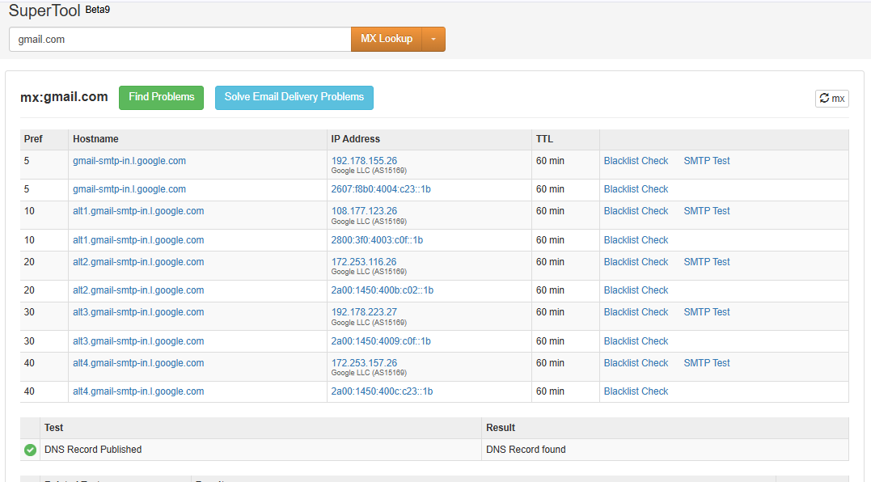
Result
The MX records of gmail.com were successfully retrieved using the MXToolBox tool. The mail servers responsible for handling Gmail emails were displayed successfully.

Experiment 2: Email Header Analysis

Aim
To analyze the email header using the MXToolBox Email Header Analyzer.

Tool Required
- Gmail
- Web Browser
- MXToolBox Email Header Analyzer

Procedure
- Open Gmail in a web browser.
- Open any email and click Show Original.
- Copy the complete email header.
- Open the MXToolBox Email Header Analyzer.
- Paste the email header into the text box.
- Click Analyze Header.
- Observe the analysis results.
- Capture screenshots of the output.
OUTPUT IMAGE
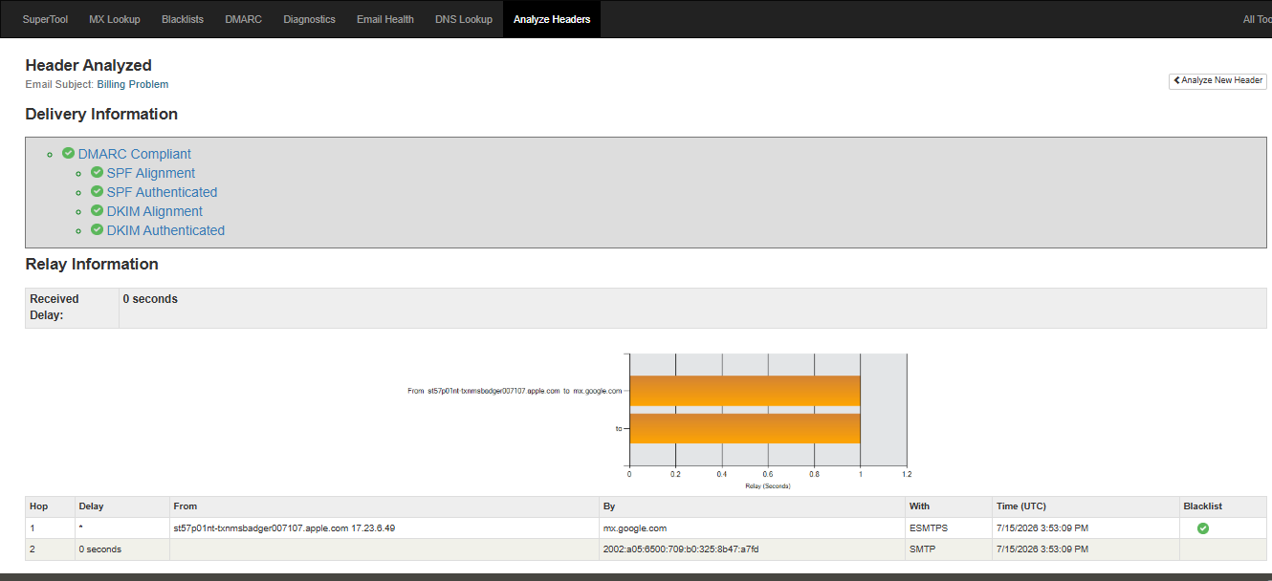
Figure 2.1: Email Header Analysis Result
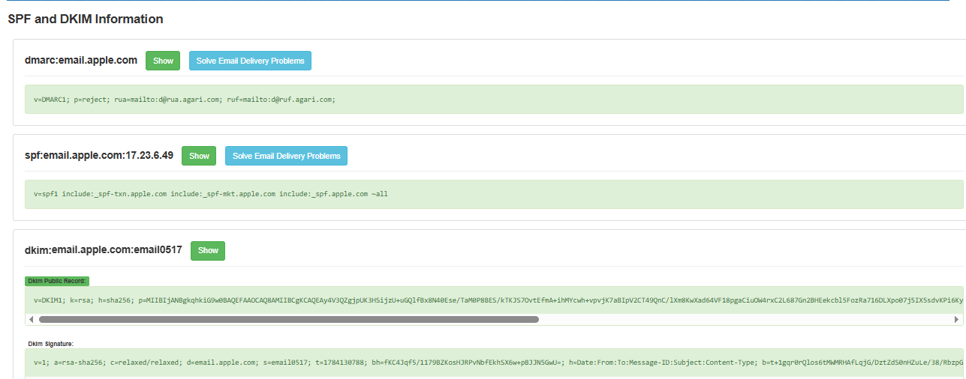
Figure 2.2: SPF, DKIM and DMARC Information

Experiment 3: 20 Networking Commands

1. IP Configuration
ipconfig

2. Detailed IP Configuration
ipconfig /all

3. Test Internet Connectivity
ping google.com

4. Display Computer Name
hostname

5. Display MAC Address
getmac

6. Display ARP Table
arp -a

7. Display Active Network Connections
netstat

8. Display Connections with Process ID
netstat -ano

9. Trace Route to Google
tracert google.com

10. Analyze Network Path
pathping google.com

11. DNS Lookup
nslookup google.com

12. Display Routing Table
route print

13. View Computers on Network
net view

14. Display Current User
whoami

15. Display System Information
systeminfo

16. Display Running Processes
tasklist

17. Show Saved Wi-Fi Profiles
netsh wlan show profiles

18. Show Network Interfaces
netsh interface show interface

19. Retrieve Google Webpage
curl google.com

20. Display Routing Table (Netstat)
netstat -r

Experiment 4: Nmap Tool
